**Reward Incentive System**

**Installation Guide and User Guide**

**Installation Guide:**

* Install Java (JDK 1.8).
* Install MySQL.
* Create one folder, put Reward Incentive System- jar file, application.property file, bat file in that folder.
* Along with this we have one folder named “RewardExcel” where all config and template files are stored and path of this folder is mentioned in application.property file.
* To run the project, double click on bat file.

**User Guide:**

Open project URL in browser.

1. Login screen: Enter Username and password and click on LOGIN button.

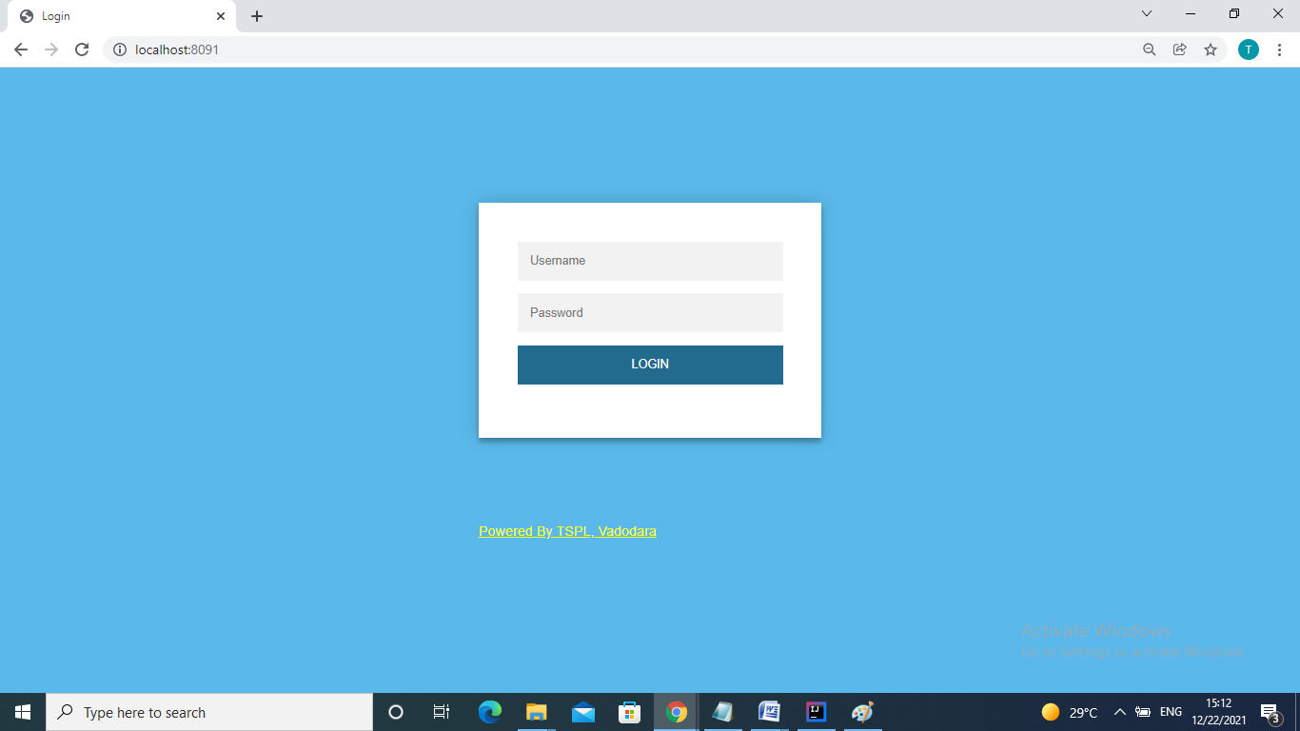

If user entered wrong credentials then message will be displayed “Invalid username/password”.

If user entered correct credentials then home page will be displayed.

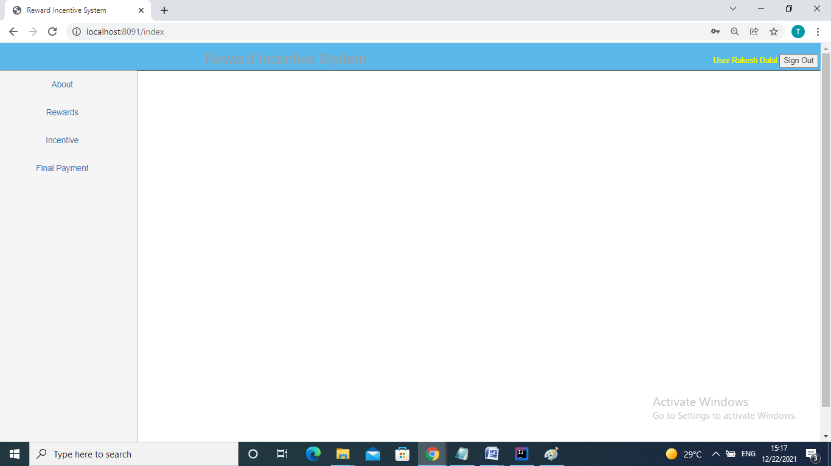

On home Page, links are shown:

* About
* Reward
* Incentive
* Final Payment

About: Provide overview of Reward Incentive System.

Reward: Provide features for monthly reward calculation and display reward date wise, employee wise and loom wise, unlock reward and to add/update/delete reward slab master.

Incentive: Provide features for monthly Incentive calculation, monthly attendance calculation, display incentive employee wise, and unlock incentive and add/update/delete incentive criteria master.

Final Payment: Provide feature for final payment of reward and incentive.

**Reward:**

* Monthly Reward
* Daily Reward
* Employee Reward
* Loom Reward
* Reward Slab Master
* Unlock Reward

Reward Page

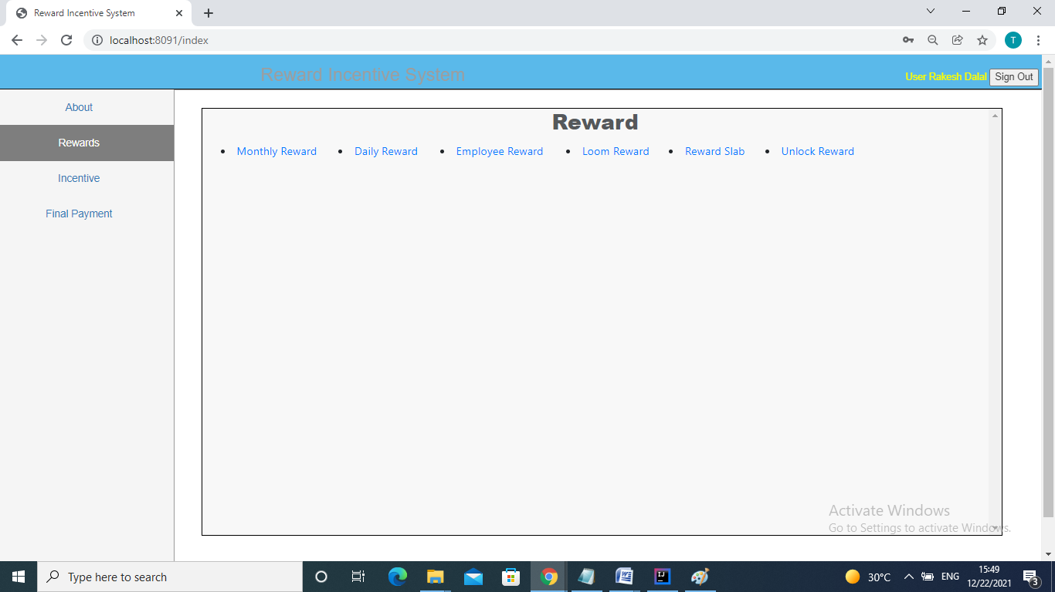

**Monthly Reward:**

When user click on Monthly Reward link then page will displayed as follows:

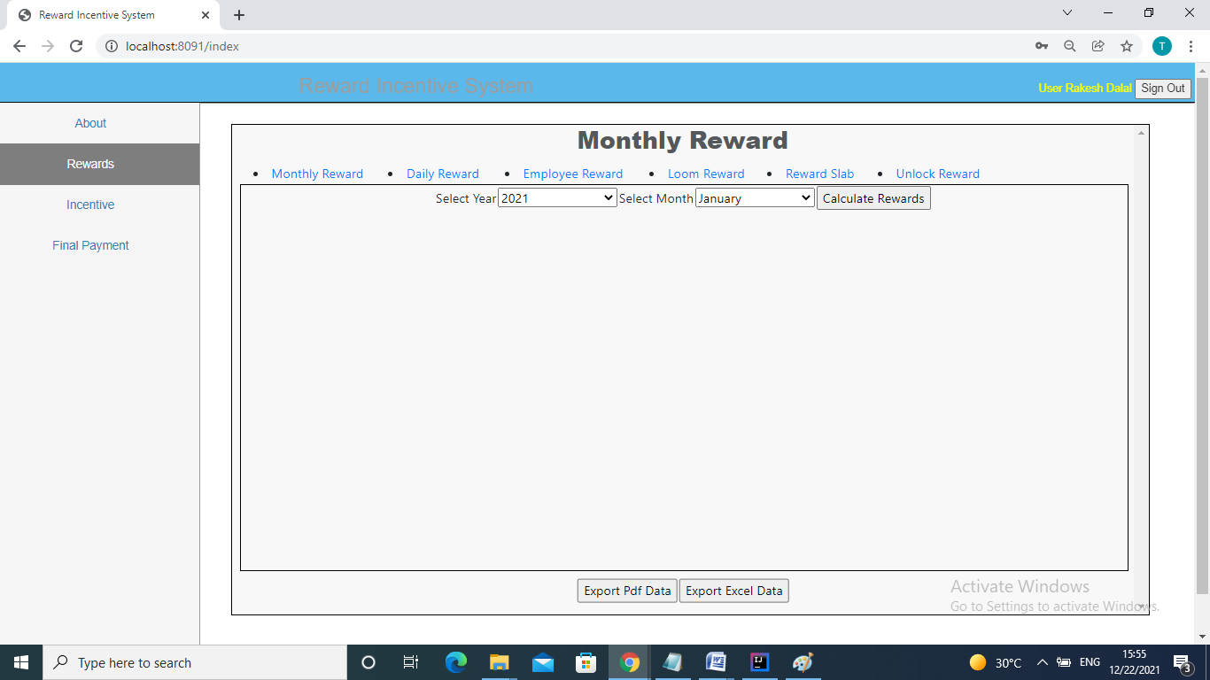

Select year and month from dropdown list and click on Calculate Rewards button.

System will display reward for selected month and year. If reward is calculated first time for selected year and month then system will calculate it from scratch and result will displayed on same page. If reward is already calculated then system will display rewards and show message “Rewards already calculated”.

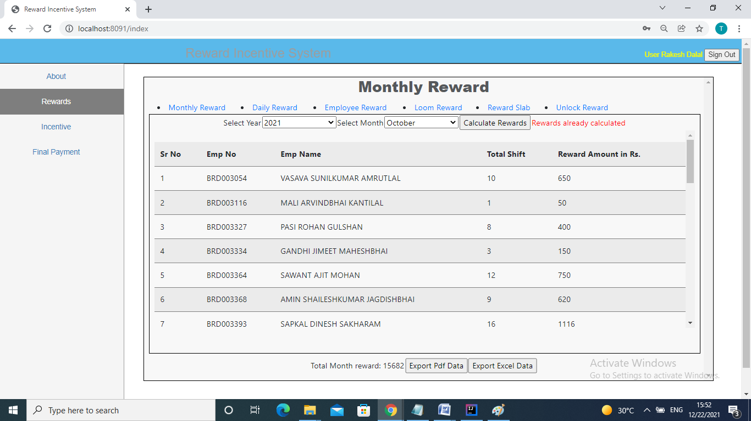

Buttons provide at the bottom “Export PDF Data” and “Export Excel Data” can export reward in PDF and Excel format. In every feature of Reward Incentive System, “Export PDF Data” and “Export Excel Data” these two buttons provided.

**Daily Reward:**

Select from date and to date and click on submit button then reward will be displayed for selected criteria.

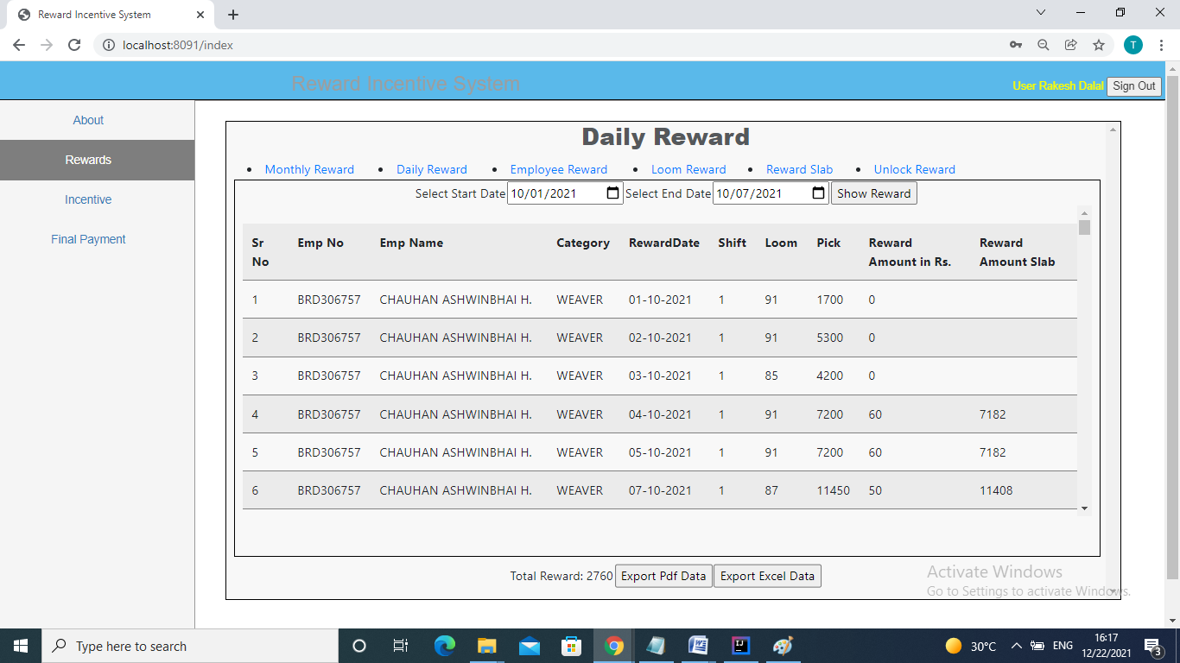

**Employee Reward:**

Select employee id, start date and end date and click on Show Reward button

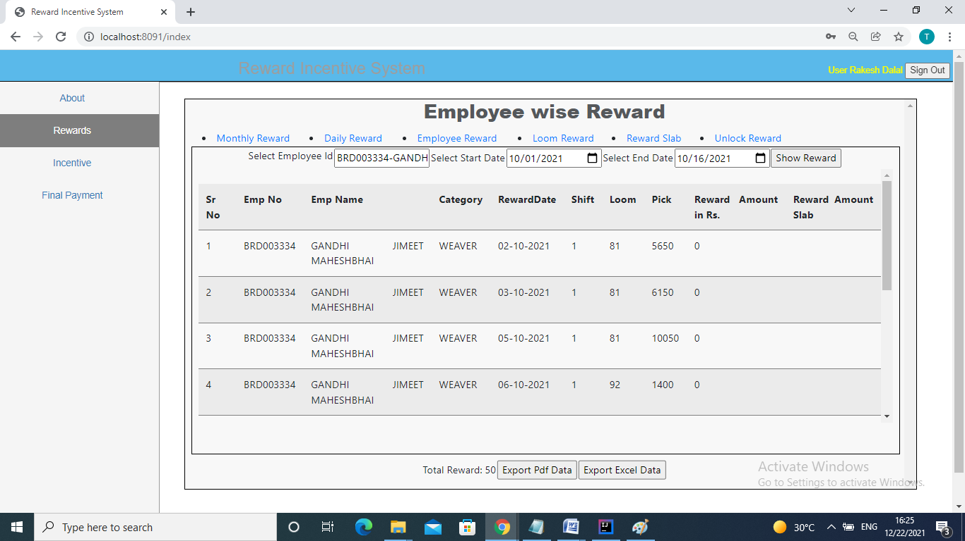

**Loom Reward:**

Select loom, start date, end date and then click on Show Reward button.

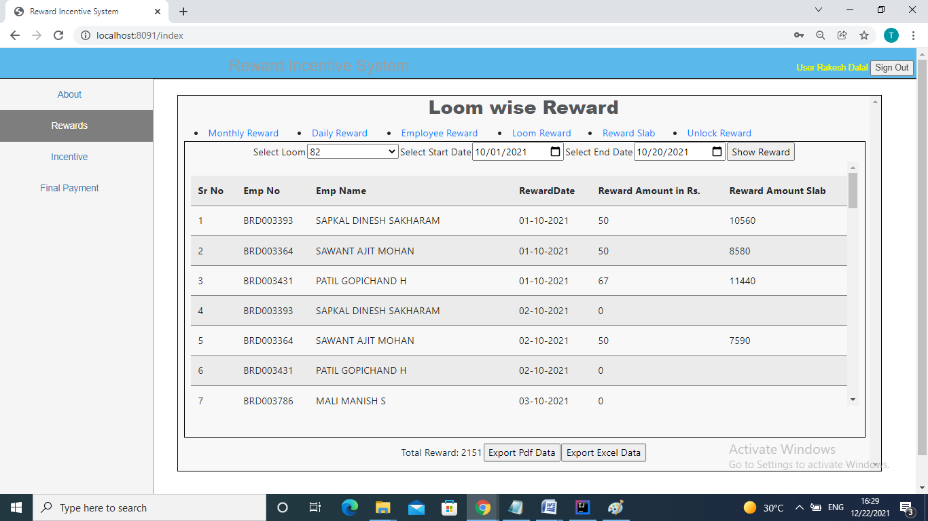

**Reward Slab Master**

Here, Reward slab master table gets display.

At the bottom 3 buttons availed for user to add new slab, to update existing slab and to delete existing slab.

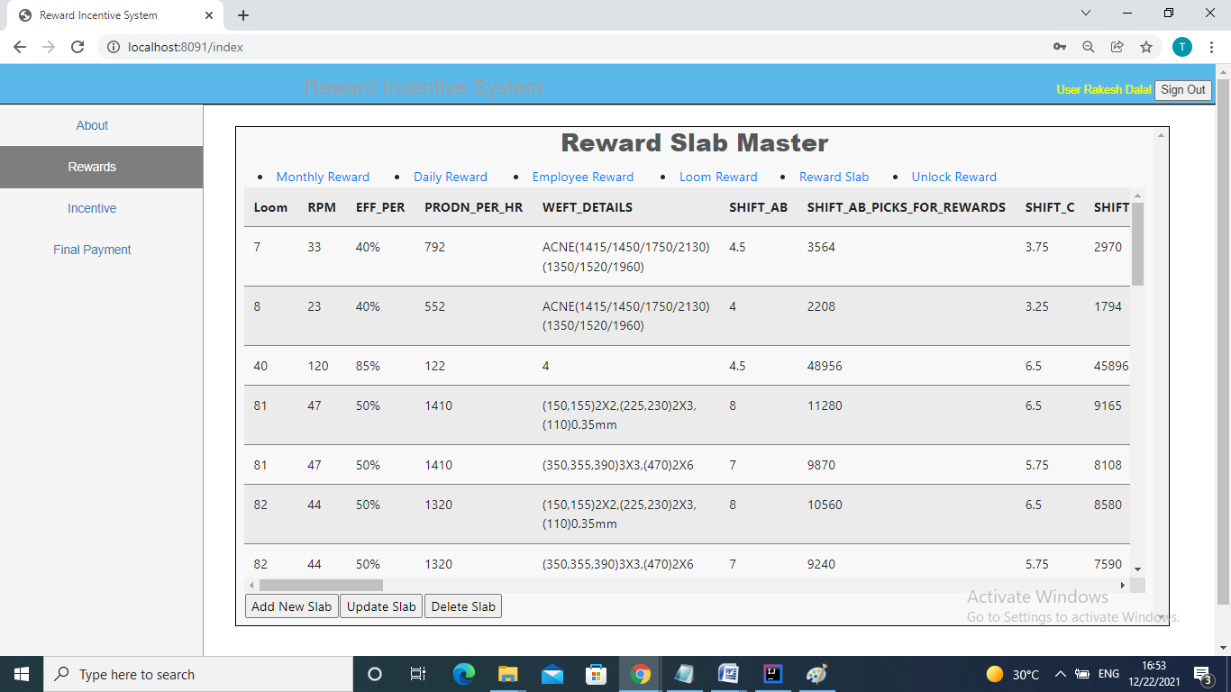

**Unlock reward:**

This facility availed to recalculate reward. Here select year and month to unlock reward.

**Incentive:**

* Monthly Incentive
* Monthly Attendance
* Employee Incentive
* Incentive Criteria
* Unlock Incentive

**Monthly Incentive**

When user click on Monthly Incentive link then page will displayed as follows:

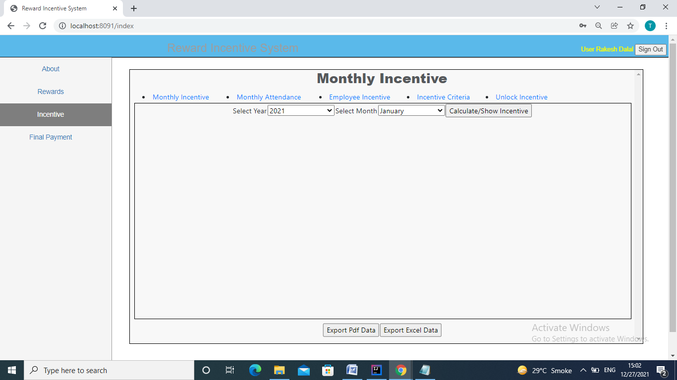

Select year and month from dropdown list and click on Calculate Incentive button.

System will display incentive for selected month and year. If incentive is calculated first time for selected year and month then system will calculate it from scratch and result will displayed on same page. If incentive is already calculated then system will display incentive and show message “Incentive already calculated”.

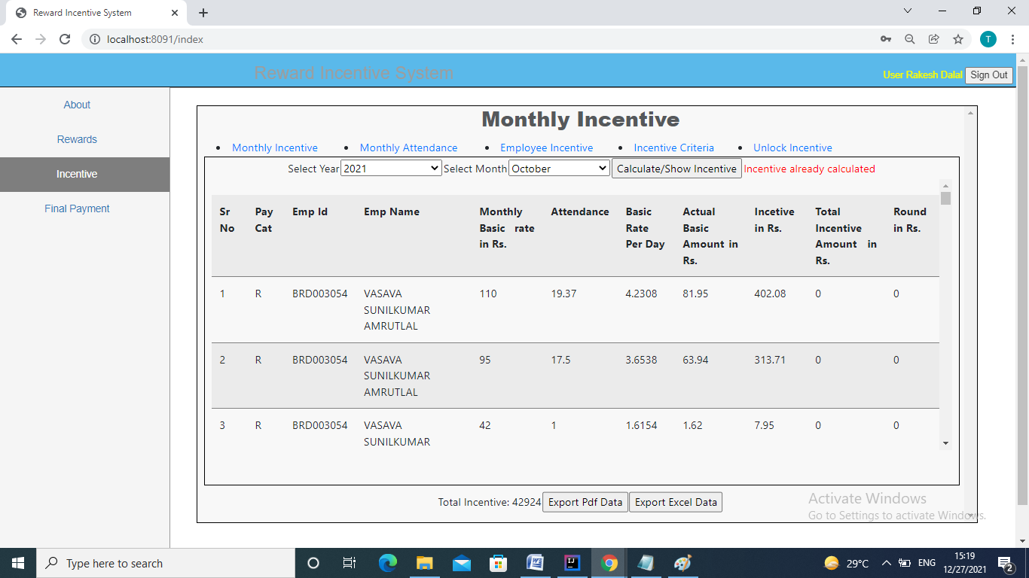

**Monthly Attendance**

This feature display monthly employee attendance for selected month and year.

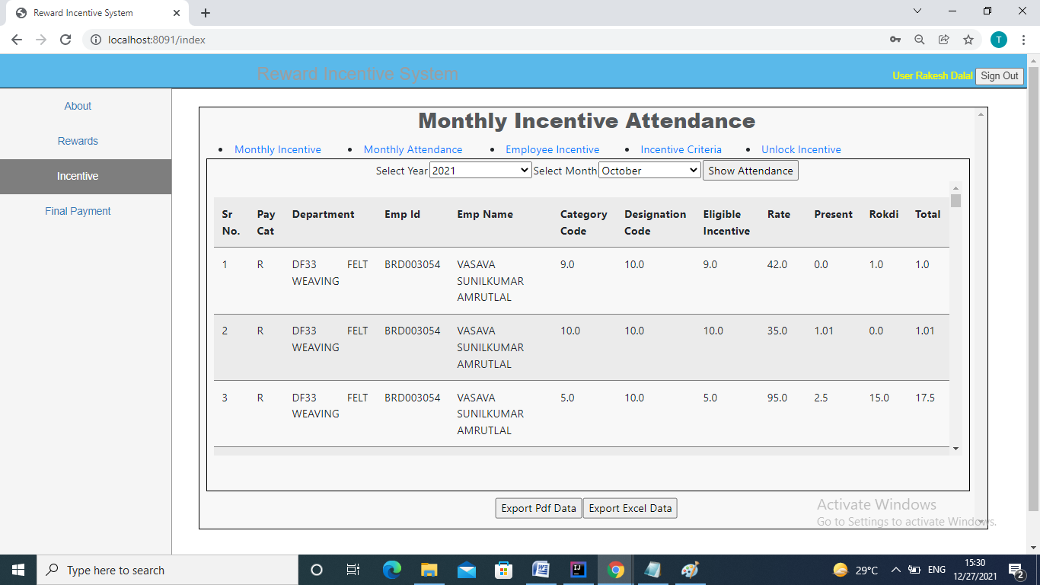

**Employee Incentive:**

Select employee id, year and month and click on Show Incentive button. Incentive will display for selected employee id, year and month.

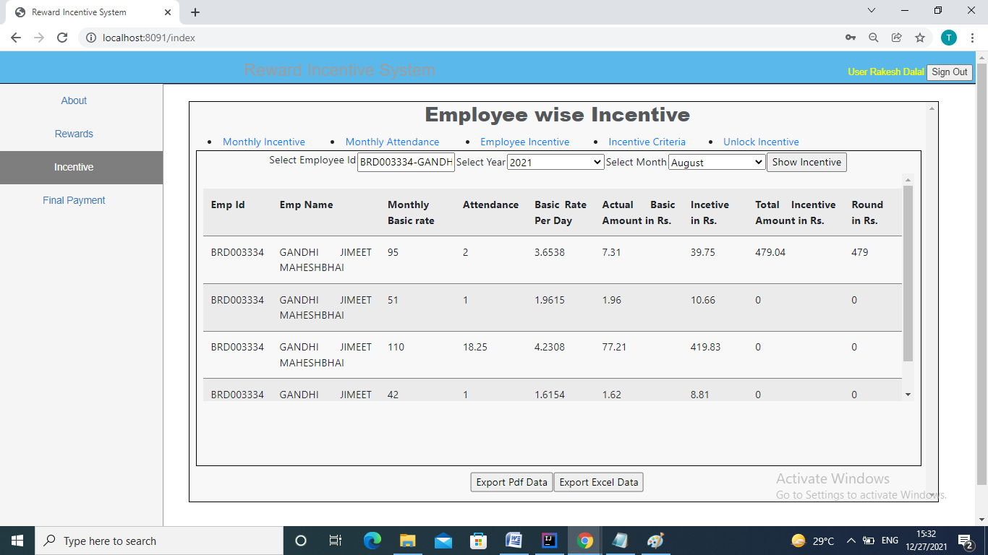

**Incentive criteria**

Incentive criteria master will be displayed. Here user can add new incentive criteria, update incentive criteria, delete incentive criteria.

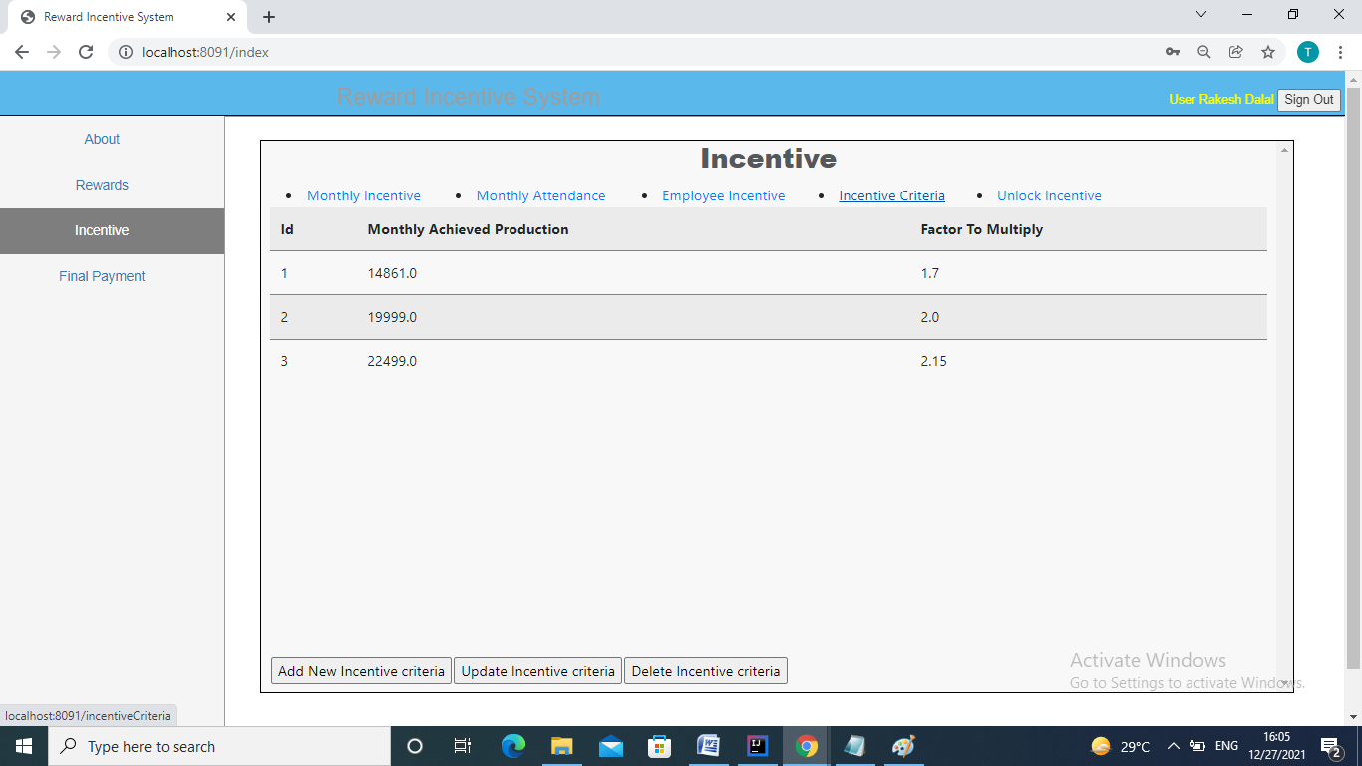

**Unlock incentive:**

This facility availed to recalculate incentive. Here select year and month to unlock incentive.

**Final Payment:**

* Incentive
* Incentive Final Payment
* Reward
* Reward Final Payment

**Incentive:**

Incentive with Ptax will be displayed here.

Separate PDF and excel will be exported for Regular employee payment and Voucher employee payment.

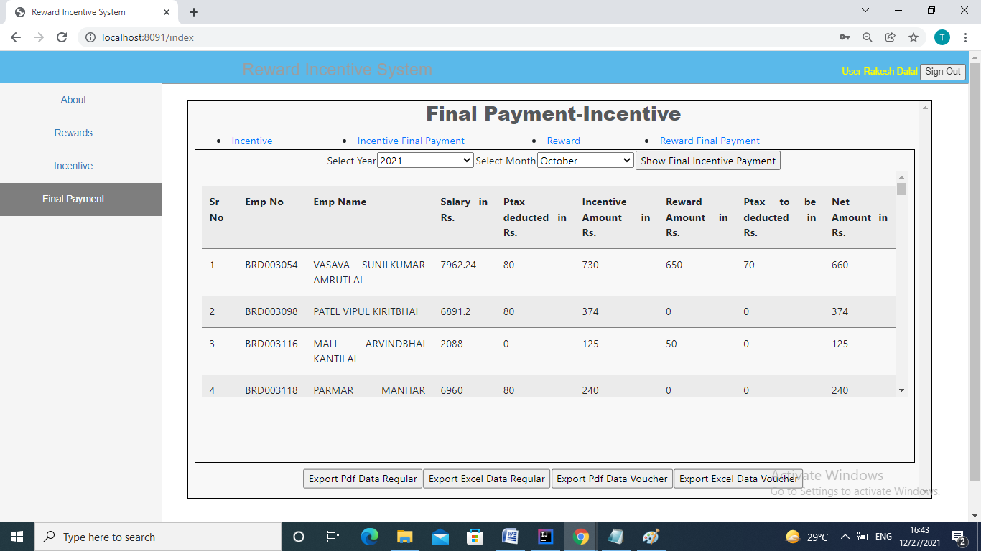

**Incentive Final Payment**

Here, final payment of incentive for selected month and year will be displayed.

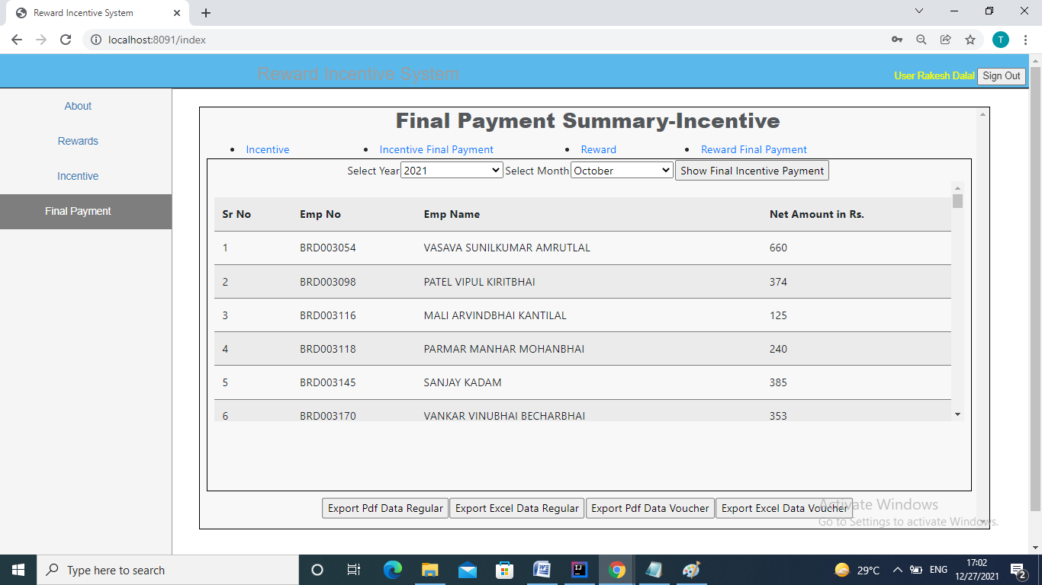

**Reward:**

Reward will be displayed for selected month and year.

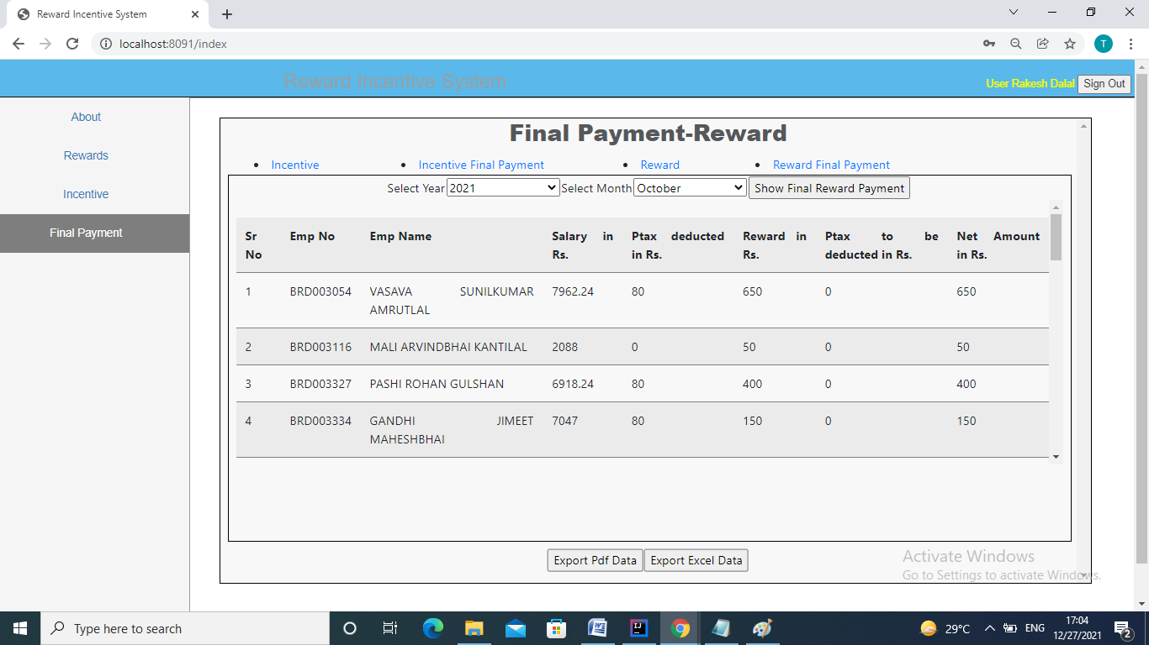

**Reward final payment:**

Final payment for reward will be displayed for selected month and year.

